First Call for Papers and Opening of Registration
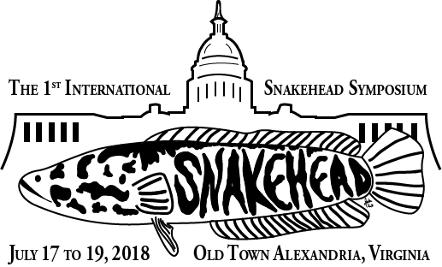

First International Snakehead Symposium

- Talks are encouraged on aspects of management and control particularly for Northern Snakehead as well as status, distribution, and pathways for introduction or spread of snakehead species in the United States.
- Observed impacts of established populations are of particular interest.
- Any aspect of any species of snakehead biology and/or ecology will be considered.
- Oral presentations should be 20 minutes total including 5 minutes for questions and will be grouped in logical order within the conference.
- Posters are welcome (maximum size 3’ X 6’).
- Abstracts should be sent to john.odenkirk@dgif.virginia.gov by April, 10 2018.
- Abstracts should be 250 words or less and should include the author(s) contact information and affiliation, choice of oral or poster presentation, and desire to publish within the proceedings.
- Presenters must pay normal registration fee.
- Travel stipends may be available for presenters and will be evaluated based on traveler’s need, presentation content and funding availability.
- Publication of manuscripts following the symposium will be optional although encouraged.
- Papers will be published as compilation (proceedings) in an AFS book and will undergo peer review.
- To save money and help with planning, please register early by clicking this link: https://units.fisheries.org/va/the-first-international-snakehead-symposium/registration/ If using pay-by-check option, make checks payable to VA Chapter AFS and mail to John Odenkirk, VDGIF, 1320 Belman Road Fredericksburg VA 22401

